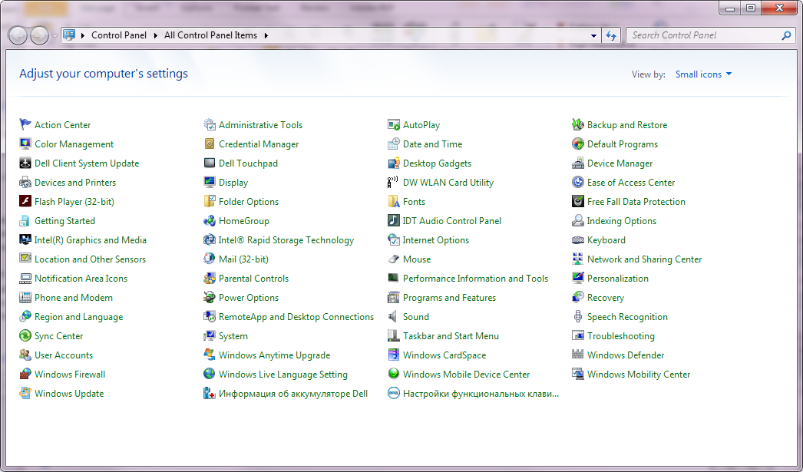
Depending on the Firewall settings on a customer computer, it may be necessary to adjust the exceptions in the Firewall to allow port 7894 so that the PigCHAMP Mobile Program can communicate with the Handheld. In order to do this, please follow the steps as outlined.
Figure 1
Go to Start> Control panel (Figure 1) If your view does not look the same as depicted in the screen in the top right hand corner of your control panel screen is a ‘View by’ option, change this to small icons. Next select the Windows Firewall option.
When the firewall settings appear (Figure 2) on the left hand side will be an option for ‘Advanced settings’, select this option. An additional window will now appear (Figure 3).
Figure 2
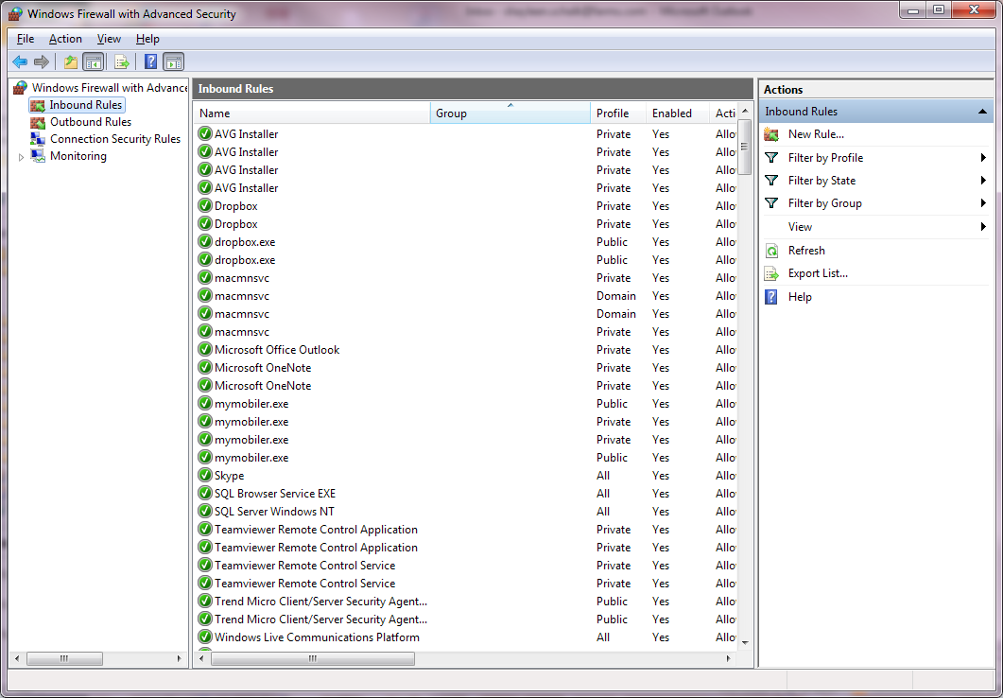
We need to adjust the Inbound Rules, to allow the handheld to send data to the computer. In the Advanced Settings window on the left pane we need to select the ‘Inbound Rule’ option. On the right hand pane an option for a ‘new rule’ will appear (Figure 3) select this option.
Figure 3
Figure 4

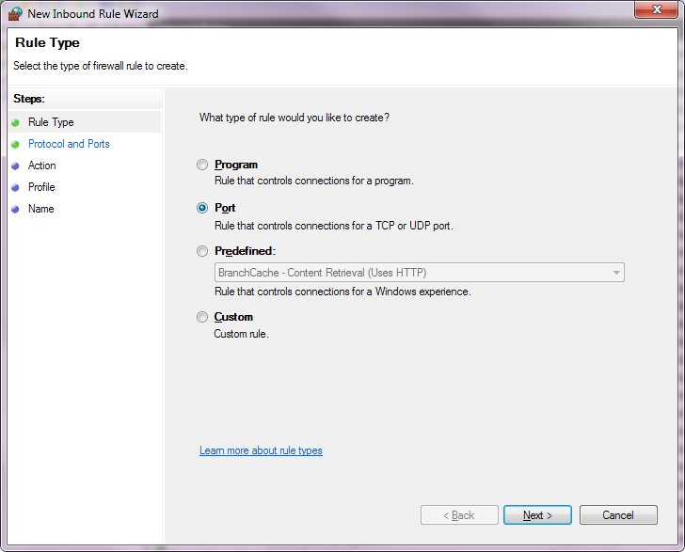
For Rule Type we need to add a Port, select the Port option on this screen (Figure 4) and then select next.
The following screen allows us to select whether the rule applies to TCP or UPD ports, for PigCHAMP Mobile we need to select the TCP option (Figure 5). We also only want to allow a specific port through the firewall, select the Specific Local Ports option and enter in 7894 (Figure 5), select Next.
The next screen will ask you want type of action should be taken when the connection exists, select the option to Allow the Connection (Figure 6) and then select Next.
Figure 4
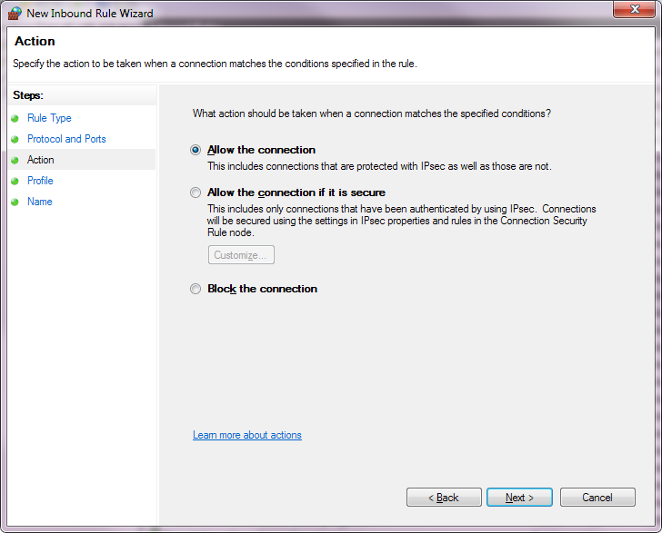
The Profile screen will then appear asking when the rule applies, by default Domain, Private and Public will be selected, leave this screen as is and select the Next Option.
Figure 5
Lastly the Name Screen will appear that will allow you to enter in a name for this new rule, this can be a name of your choosing it is recommended that you provide a name that will allow you to recognize the reason for this rule, something similar to PigCHAMP Mobile Port could be a good idea.

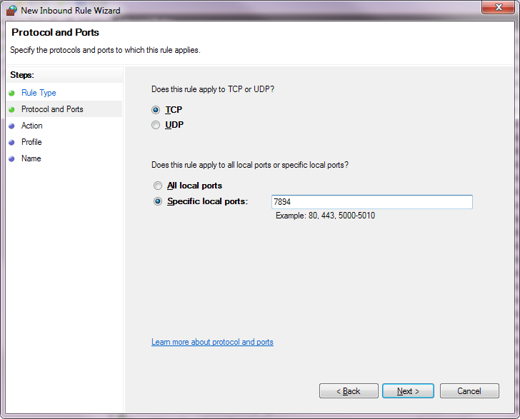
Figure 6

