1. Configured Windows on my test computer to use Russian System Locale, so Russian characters show correctly on my computer:

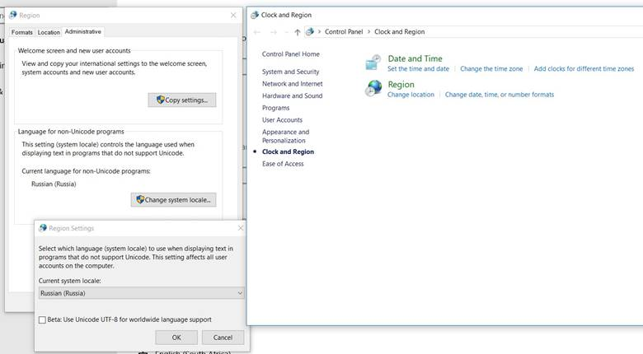

1. Opened a Russian database in PigCHAMP v7 using Russian language at signon

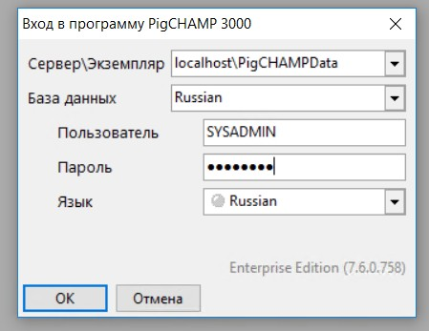

1. Ran the Service Performance Summary report

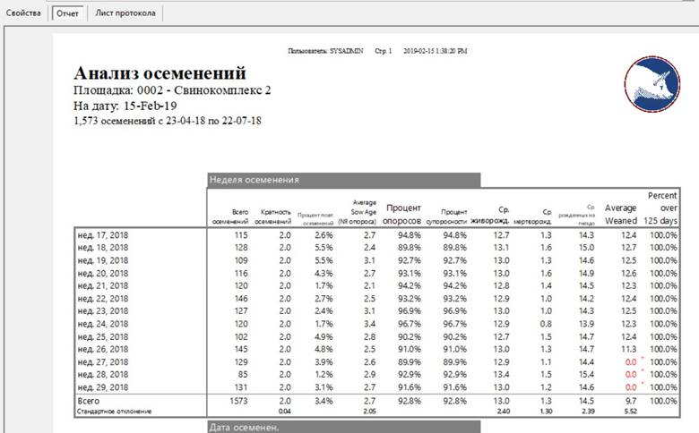

1. Looked at the Trace List for this report

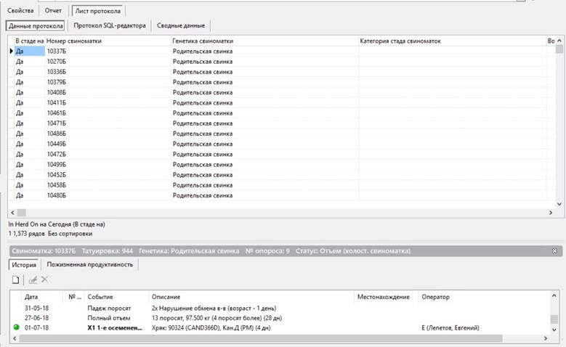

1. Exported the Trace List to Excel (csv) and then opened my Russian Trace List.csv file in Notepad to verify that the characters were showing up in Russian after being exported from PigCHAMP.  It appears to be Russian to me.  Note:  This step is not necessary to export the data, but I wanted to make sure it was exporting from PigCHAMP correctly.

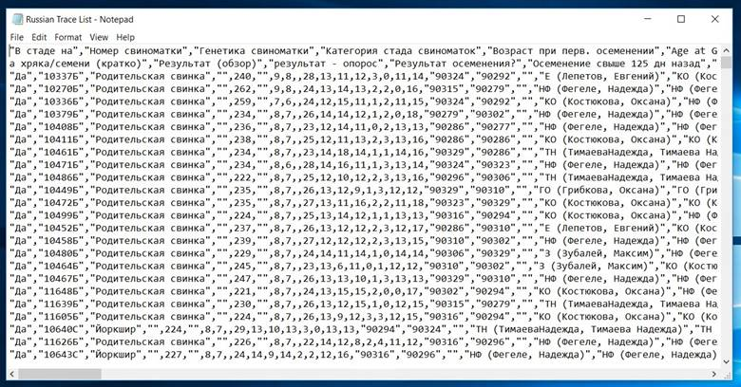

1. Opened up MS Excel – blank spreadsheet, clicked on Data > From Text/csv

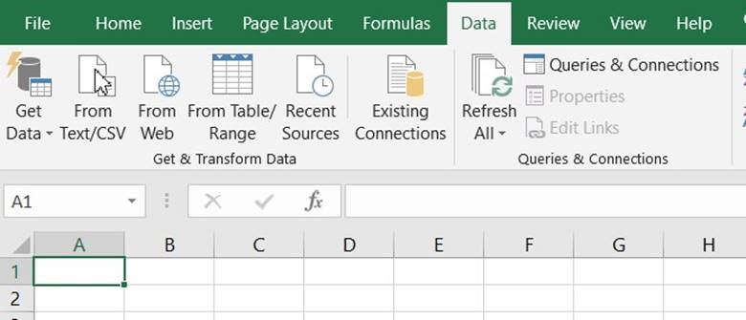

1. I chose to open the Russian Trace List.csv I just exported from PigCHAMP and clicked the Import button
2. A new screen will open up, allowing you to determine how you want to import the data.  In the File Origin box (top left) I chose 1251: Cyrillic (Windows).  Since it looked right to me, I then clicked on the Load button.

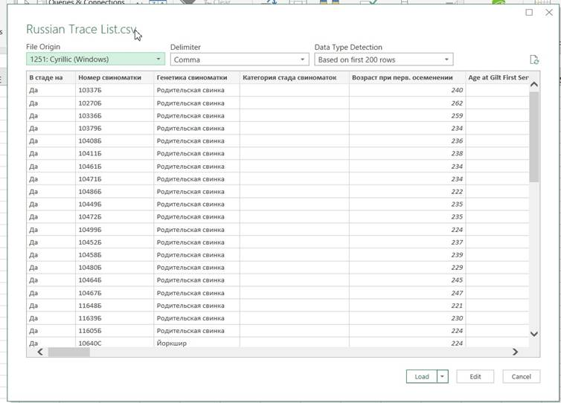       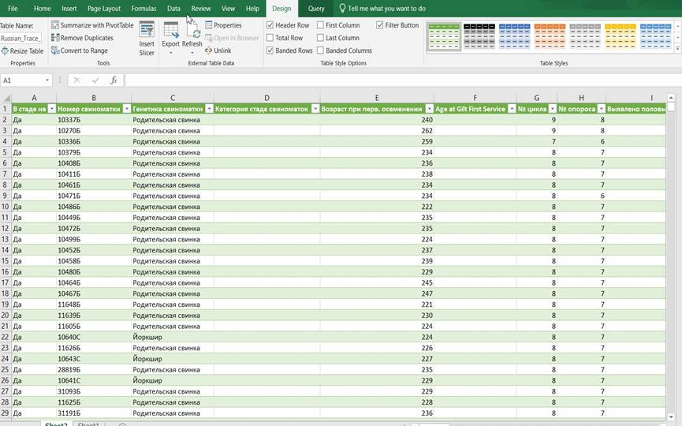

So, now I have what looks like the correct Russian characters in the Excel spreadsheet.  I do not actually understand how to read Russian, so I am just going by what the characters looked like in the PigCHAMP report and the Excel spreadsheet.  Note that I used Excel 2016, since it is what I have on my computer, but other versions of Excel have a similar data import functionality.