Question: I need to know what sows are open on a weekly basis in order to generate a breed list for the upcoming week. How do I do this in PigCHAMP?

Answer: There are a few different ways to generate this report in PigCHAMP. Try the options below and pick the one that works best for your operation!

Sows Due to be Served Report
- Select the Sows Due to be Served report from the reports tree.
- On the Properties Screen, select the time period in which to run the report, as well as the standard number of days after the complete weaning event that you breed your sows.
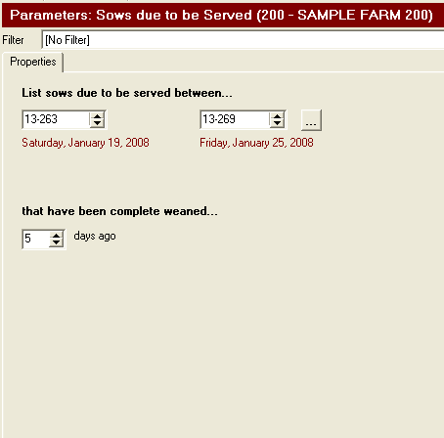
- Run the Report and view it.
- The report will group sows based on the date in which they are due to be served. By default, it will provide the sow’s identity, parity, genetics, and location. This report can be customized to display other variables.

Sows Due for Attention
- Select the Sows Due for Attention report from the reports tree.
- On the Properties Screen, select the time period in which to run the report, select the standard number of days after the complete weaning event that you breed your sows, and also select Weaned.
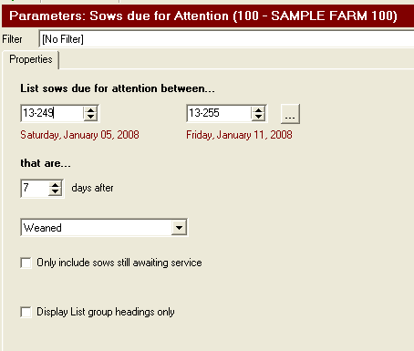
- Run the Report and view it.
- The report will group sows based on the date in which they are due to be served. By default, it will provide the sow’s identity, genetics, parity, and location. This report can be customized to display other variables.

Search for Pigs Option
- Click on the Search for Pigs Icon in the Settings Tool Bar
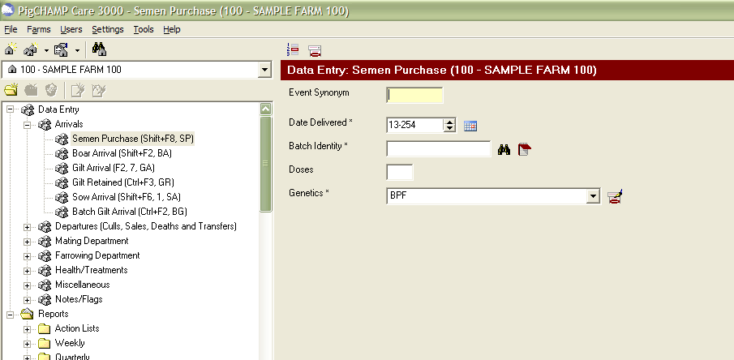
- The Search for Pigs Screen will appear. Click on the STATUS Tab.
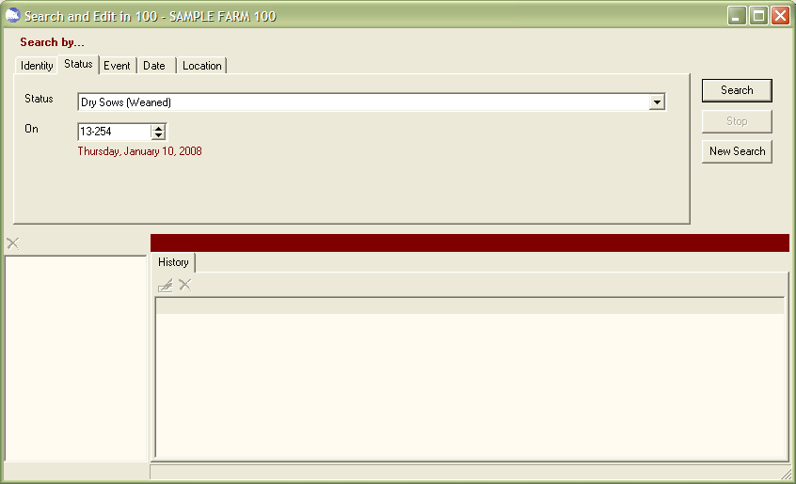
2
3
4
5
- Select Dry Sows (Weaned) from the drop down menu.
- Select the date in which to generate the list.
- Click on Search. The list of sows will be generated, as shown below.
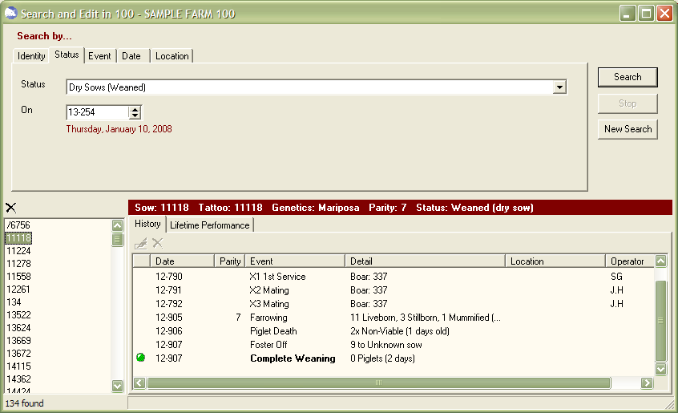
- To print the list of identities, right click on one of the identities in the list and select “Create a Report Listing the Pigs Found” on the pop-up menu.
- The report, called Pig List, will be generated in the Report Queue. When it finishes processing, view and print the report. The report will provide you with the following information: Identity, Parity, Genetics, Herd Category, Location, and Status. This report cannot be customized.

Special Note: The above report will only provide you with sows that had a complete weaning as the last event. To get a list of sows that are dry due to other reasons, select Pregnancy Checked Negative or Aborted on the Status tab. You will have to run two separate reports to see the Dry Sows and the Open Sows.

