Follow the steps below:
- Left click once on + located in front of the folder labeled Reports.
- Left click once on + located in front of the desired report group.
- Left click once on the name of the first report.
- Left click once on the button with 3 dots.
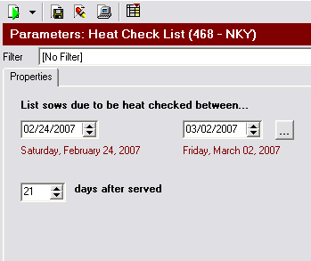
- The following screen should appear:
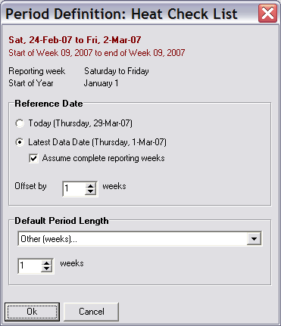
- Set your Reference Date.
  - Today
    - This will default the periods ending date to the date the report is run on.
  - Latest Data Date
    - With only Latest Data Date selected, the report will default the ending date to the last date that data was entered into the program.
    - By checking the box located in front of Assume Complete Reporting weeks, the report will default to the last complete reporting week with data entered.
***Directions for setting up Reporting Weeks are located on page 23 of the Care 3000 User Guide***
  - Offset by ? weeks
    - Adjusts the end date of the report by the number of weeks defined from the reference date. Weeks can be defined either positive (forward dating) or negative (back dating)
- Set your Default Period Length: From the drop down box, users are able to choose one of the following.
  - 4 Weeks to Date
    - Year broken out into 4 week intervals. 13 - 4 week intervals within a year. Beginning with the first week in defined year. Will display dates based on where the reference date falls within the 4 week interval. Example: In January reference date in the 3rd week. Default dates displayed will only be the 3 weeks.
  - Quarter to Date (13 Weeks)
    - Current quarter begin date to reference date
  - Half Year to Date (26 Weeks)
    - Half year date to reference date
  - Year to Date (52 Weeks)
    - Beginning of year date to the reference date
  - Rolling 4 Weeks to Date
    - Reference date – 4 weeks
  - Rolling Quarter to Date (13 Weeks)
    - Reference date – 13 weeks
  - Rolling Half Year to Date (26 Weeks)
    - Reference date – 26 weeks
  - Rolling Year to Date (52 Weeks)
    - Reference date – 52 weeks
  - Other Weeks
    - Number of weeks from the reference date
  - Other Days
    - Number of days from reference date
- Left click once on OK.
- If choosing to select, deselect, or change any setting on the report parameters page, do so now. Also, apply any filters that are to be permanently set for this report.
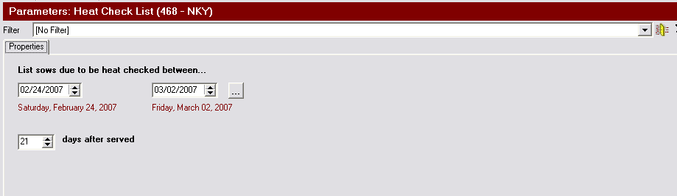
Example: Choosing to change the number of days after served from 21 to 25. To keep the report at 25 days, change days prior to step #10.
- Left click once on the Save Current Report Settings Button.
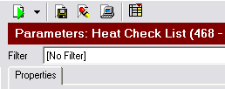
- The following message will appear after clicking on the Save button.

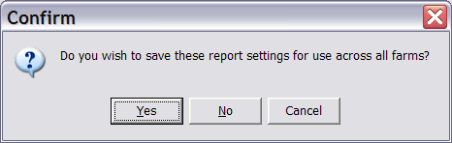

- By clicking Yes, the report will keeping the saved setting the same for all farms on the program. By clicking No, the report settings will only be saved for the current farm.

- Left click once on OK.
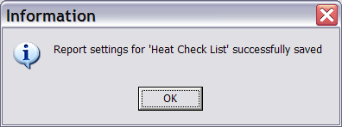
- The report is now saved and will run each time according to the period settings that were selected.

Other information:
- To change the report back to the system defaults, choose the Restore System Defaults button.

- To change the report back to the last saved format, choose the Reset Back to Last Saved Report Setting button.

