Follow the steps below:
- Select the farm group from the farm drop down box.
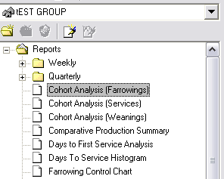
- Left click once on + located in front of the folder labeled Reports.
- Left click once on the Comparative Production Summary.
- Set up the dates for the report to run.
- This report will look very similar to the Performance Trend Analysis/Performance Analysis by Group. The report lists the farms in the group along the top of the report. The performance variables will be listed down the side of the page.
Other reports available for report groups will combine all farms in the group and give performance numbers for the group as a whole.

