Follow the steps below:
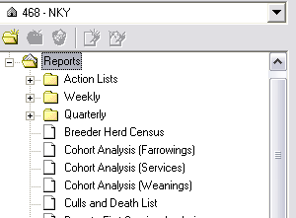
- Left click once on + located in front of the folder labeled Reports.
- Left click once on the button called Create a New Report Group (located under the farm selection dropdown box).
- The new report group folder can now be renamed.
- After renaming the folder, press Enter.
- Follow the directions below for each report that you would like to put into your new report group.
  - Left click once on the report name.
  - Left click and keep holding down the mouse button.
  - While still holding the mouse button down, drag the report to your new Report Group Folder (the name of the folder should be highlighted).
  - With the new Report Group folder highlighted, let go of the mouse button.
  - Left click once on the new Report Group folder. The report should now be listed in the new Report Group.
**Repeat these steps for each report to be added to the new Report Group.
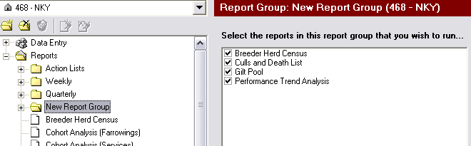
- After the group and its reports are established, the report group is ready to run its reports.
- Left click once on the Report Group folder that needs to be run.
- Left click once on the green arrow button located above the Report Group screen.
- The reports should now be running.

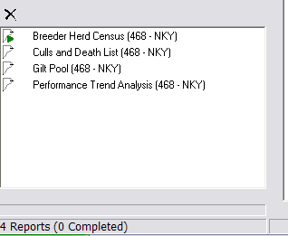

Other information:
- To delete a report out of the report group
  - Left click once on + in front of the report group.
  - Left click once on the name of the report that needs to be removed from the group.
  - Left click once on the button labeled, Remove This Report From the Report Group.
