PCLMS Troubleshooting Guide

PCLMS stands for PigCHAMP Management Licensing Management Service. It is a small piece of software that is installed ONLY with PigCHAMP Enterprise software (not Standard). Its job is to verify the license and provide a connection for client computers.

The Cannot Connect to PCLMS error indicates that the PCLMS service cannot be accessed from the computer you are using to run PigCHAMP software. This can occur for a number of different reasons. Follow the procedure below to get PCLMS working correctly.

- Verify that PCLMS is running on the server

Click on Start > Control Panel > Administrative Tools > Services. You should see PCLMS listed as one of the services:

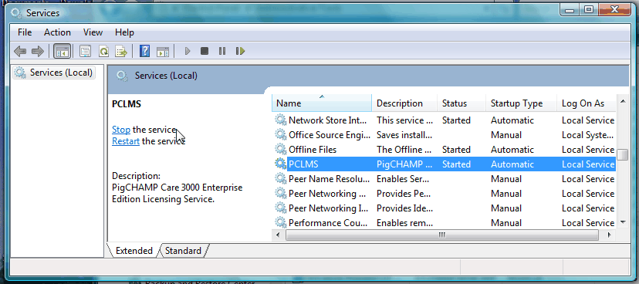

The status should be Started and the Startup Type should be Automatic. If the service is not started, right-click on PCLMS and choose Start.

If the service will not start, change the logon account for PCLMS:
- Right-click on PCLMS, choose Properties
- Select the LogOn tab
- Fill in the radio button in front of This Account:, click on Browse
- In the Object name box, type LOCAL SERVICE, click on Check Names, then OK
- Delete the password in the password and confirm password boxes
- Click on Apply, then OK
- Try to start PCLMS again

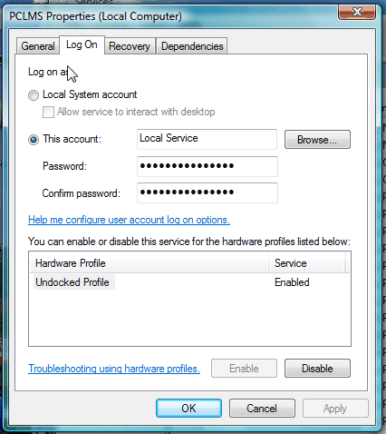

If PCLMS still will not start, contact PigCHAMP Customer Support.

- Verify that firewalls are not blocking the PCLMS port

If the PCLMS service is running, but will still not connect, verify that the IP address for PCLMS is correct. If it is, firewalls may be blocking the PCLMS service port. Turn off internal firewalls temporarily. Try to start PigCHAMP. If PCLMS will connect with firewalls off, you know firewalls are the issue.

Consult the PigCHAMP Enterprise Installation Manual to set up Windows firewalls correctly to allow PCLMS through the firewall. See CRM #210 – Enterprise Installation Manual for more information.

