Backing up Care 3000 Farm Data in Windows Vista
It is very important to backup up your farm data prior to installing an update and on a regular basis. A regular backup will help prevent from lost data. To transfer farm data BETWEEN computers, please use the Import/Export function located in the Care 3000 program.

To create a backup of your farm data, follow the steps outlined below:
- Close out of the PigCHAMP Care 3000 Program.
- Click on the Start button located in the lower left hand corner of your computer screen.
- Click on “All Programs”
- Click on PigCHAMP Care 3000
- Single-Right-Click on the Backup and Restore Utility.
- Single-left-click on “Run as Administrator”. If the User Account Control box pops up, click on Allow.
- The following pop-up will appear:
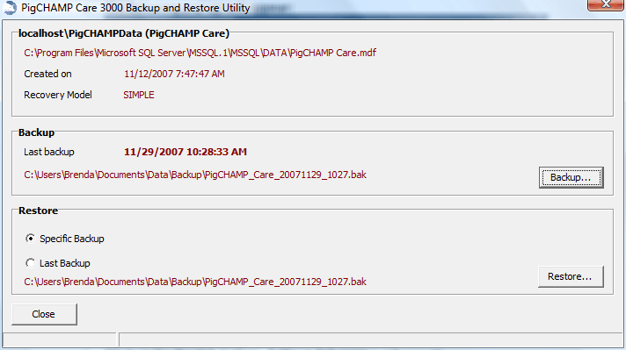

- Click on the Backup button. A “Save As” screen will appear
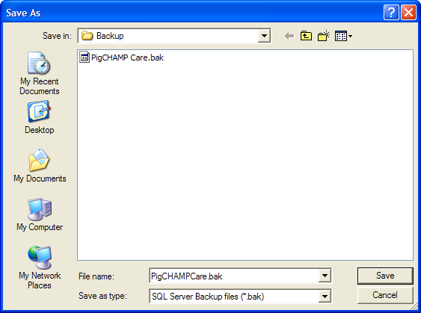

- Choose backup file location. Note: Do not save directly to a flash drive. Save to your computer first and then move it to the flash drive later.
- Click on Save
- Once completed, the following will appear
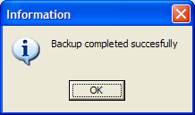
- Click Close in the PigCHAMP 3000 Backup and Restore Utility

Restoring Care 3000 Data on Windows Vista
Do not use restore unless directed by PigCHAMP personnel or data may be lost.
To restore a backup copy of farm data, follow the steps below:
- Close out of the PigCHAMP Care 3000 Program.
- Click on the Start button located in the lower left hand corner of your computer screen.
- Click on “All Programs”
- Click on PigCHAMP Care 3000
- Single-Right-Click on the Backup and Restore Utility.
- Single-left-click on “Run as Administrator”. If the User Account Control box pops up, click on Allow.
- The following pop-up will appear:

- Choose Last Backup or Specific Backup.
- Click on Restore.
- At the bottom of the screen it will say “Please wait, Restoring the database…

- Once the process has completed, the following will appear.
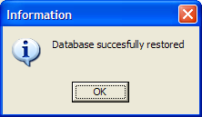

- Click on Ok
- Click Close in the PigCHAMP 3000 Backup and Restore Utility

