Pre-Wean Mortality Calculation

* Found on Performance Trend Analysis - Piglets Weaned Section

Pre-wean Mortality Calculation =
For sows weaned in period (# born alive) – (# weaned)/(# of Liveborn for sows weaned in period)*100

The prewean mortality calculation goes back to the sows weaned and THEIR liveborn piglets.

The best way to get this information is by clicking on the value under Litters Weaned. The example below, I have clicked on number 59 and am able to see the all of the weaned sow’s history (born alive and weaned). I added all the born alive numbers together and all the weaned sow numbers and plugged into the equation above.
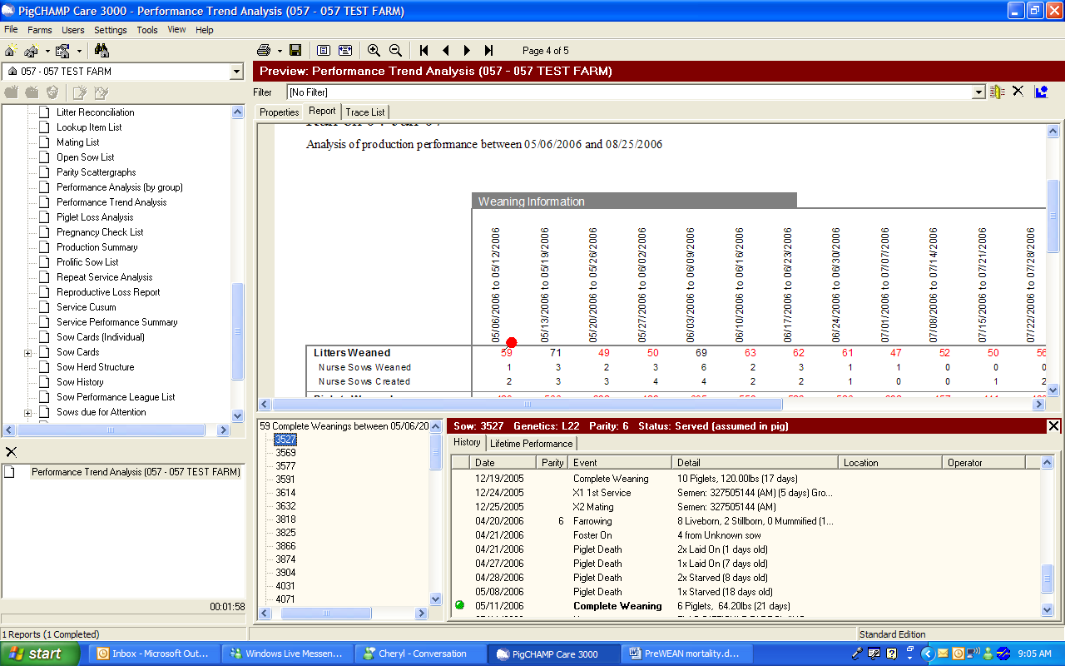

Nurse Sow / partial weans:
Say for example you had 49 sows weaned last week: 2 of them were nurse sows. All 49 sows will be included in your number, but the nurse events and partial wean events is where it gets a little confusing.

Example #1: A sow nurse weaned in the time period selected. You would count her born alive at farrowing against the number farrowed and the number that she nurse weaned against the number weaned.

Example #2: A sow had a nurse wean, but her complete wean was in the time period selected on the report. You would count her born alive at farrowing against the number farrowed and the number that she NURSE WEANED against the number weaned.

Example #3: A sow had a partial wean, but her complete wean was in the time period selected on the report. You would count her born alive at farrowing against the number farrowed and the number that she partial weaned PLUS the number complete weaned against the number weaned.

