Sow Performance List (DOS) – Sorted by ID
In Care 3000

Follow the steps below:
- Left click once on the report, Breeder Herd Census.
- Left click once on the Create a New Report Button (located under the farm selection dropdown box).
- You can now name the report Sow Performance List NEW.
- Left click once on Sow Performance List NEW to choose your new report.
- Left click once on the button Select Data Items You Would Like to Include in this Report (located above the report setup screen, looks like an excel sheet).
- You should now see the Data Attribute Selection screen. Left click once on the Add New Reporting Item button (looks like an excel sheet).
- Left click once on the plus sign in front of Lifetime Summary.
- For each of the following you will need to follow this process: Left click once on the variable (listed below) and left click on add for EACH variable.
  - Av. Total Born
  - Av. Total Weaned
- Left click once on the plus sign in front of Litter.
- For each of the following you will need to follow this process: Left click once on the variable (listed below) and left click on add for EACH variable.
  - Liveborn
  - Totalborn
  - Stillborn (optional)
  - Mummified (optional)
- Left click once on Close.
- In the Data Attribute Selection screen left click once on the button called Add or modify Column Headings on List Reports.
- For items to display on the report, left click once on the item under Columns Displayed and left click once on the black arrow pointing to the left to move under the Columns Available section. Similarly for items to NOT display on the report, left click once on the item under Columns Available and left click once on the black arrow pointing to the left to move under the Columns Displayed section.

At the end it should look similar to this:
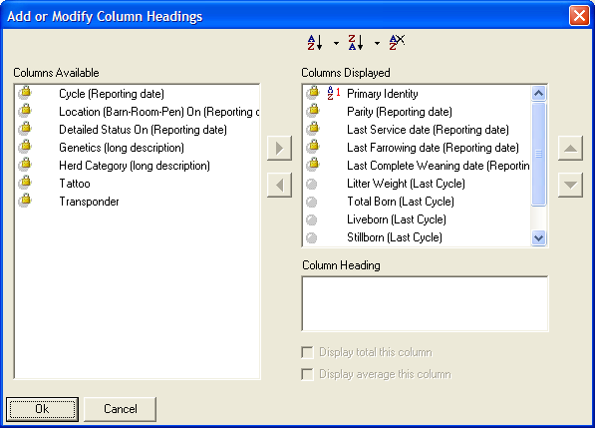
- Currently, Identity has an AZ1 in front of it. Leave the sort in front of this variable. Left click once on the variable that you would like to sort the report by.
- Left click once on OK.
- Left click once on Close.
- Uncheck the boxes for Unworked Boars and Working Boars.
- Left click once on the Save Current Report Settings button (located by the Run Report button).
- It will ask if you would like to save these setting across all farms, choose Yes.
- Run the report.
- The report should now be complete and sorted by the variables you have choosen.
- Report headers should display as below.

