Custom Litter Selection Report

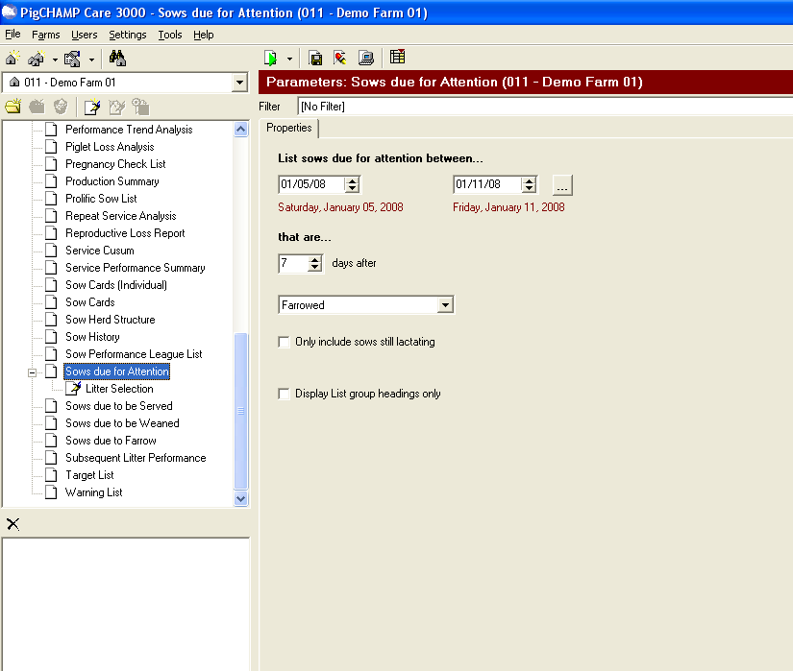
- Click on the report “Sows Due For Attention”

- Click on the “Create a New Report” icon

  - Looks like a blank piece of paper

- Then you can rename the report “Litter Selection”

- After you have renamed the report make sure you have the “Litter Selection” report highlighted

- Click the “Add Attributes” icon

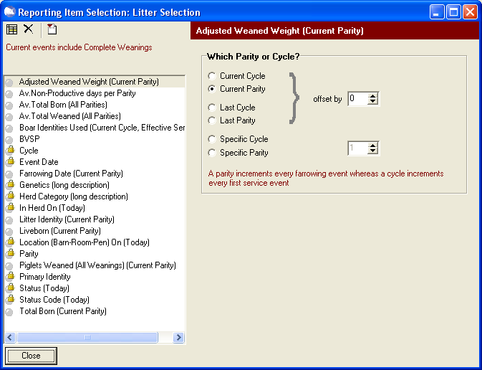
- The “Reporting Item Selection” box will come up and then you need to select “Add New Reporting Item” icon

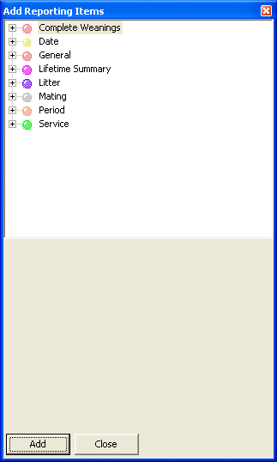
- The “Add Reporting Items” box will appear
  - This is where you will add (by double clicking each item)
    - General Section
      - Av. Non-Production days per Parity
      - BVSP
    - Lifetime Summary (if you wanted the dam’s avgs)
      - Av. Total Born
      - Av. Total Weaned
    - Litter Section
      - Adjusted Weaned Weight
      - Farrow Date
      - Litter Identity
      - Liveborn
      - Piglets Weaned (All Weanings)
      - Total Born
    - Service Section
      - Boars Identities Used

- Click Close

- Then your “Reporting Item Selection” box should appear with all the items that you selected in the left

- Next you will need to go through and make sure the following events have the following Parities or Services on the right hand side

  - Adjusted Weaned Weight
    - Current Parity
  - Boars Identities Used
    - Effective Service
  - Farrow Date
    - Current Parity
  - Litter Identity
    - Current Parity
  - Liveborn
    - Current Parity
  - Piglets Weaned (All Weanings)
    - Current Parity
  - Total Born
    - Current Parity

- Next click on your “Add/Remove Attributes to Report View” icon

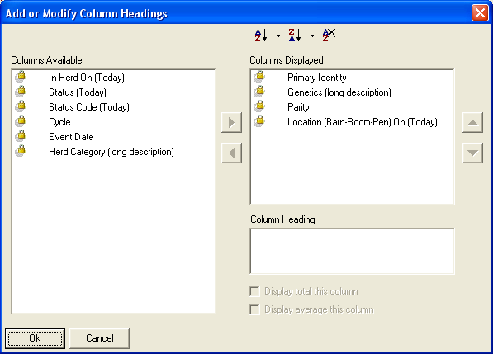
- This box should appear and you will need to remove Location (Barn-Room-Pen) from the right hand side

- Then you will need to add (by highlighting the event on the left and then clicking on the arrow pointing to the right) in the order in which you want them positioned on the report

  - Litter ID – 1st item
  - Farrow Date – 2nd item
    - Rename to Birth Date (by typing this in the bottom where it says column heading (also make sure to hit “return” after you are done typing the name)
  - Boar Identities Used – 3rd item
    - Rename to Sire
  - Av. Non-Productive days per Parity – 7th item
    - Rename to Av. NPD/Parity
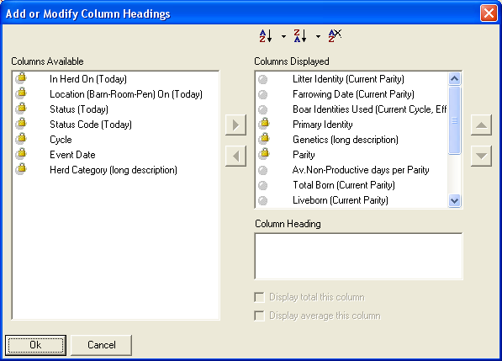
  - Total Born – 8th item
  - Liveborn – 9th item
  - Piglets Weaned (All Weanings) – 10th item
    - Renamed to Pigs Weaned
  - Adjusted Weaned Weight – 11th item
    - Rename to ADJ 21 WT
  - BVSP – 12th item
  - Av. Total Born – 13th item
  - Av. Total Weaned – 14th item

- To sort the report by Litter ID’s make sure you have Litter Identity highlighted and click the “Add To Sort Ascending” icon

- Click OK

- Click Close

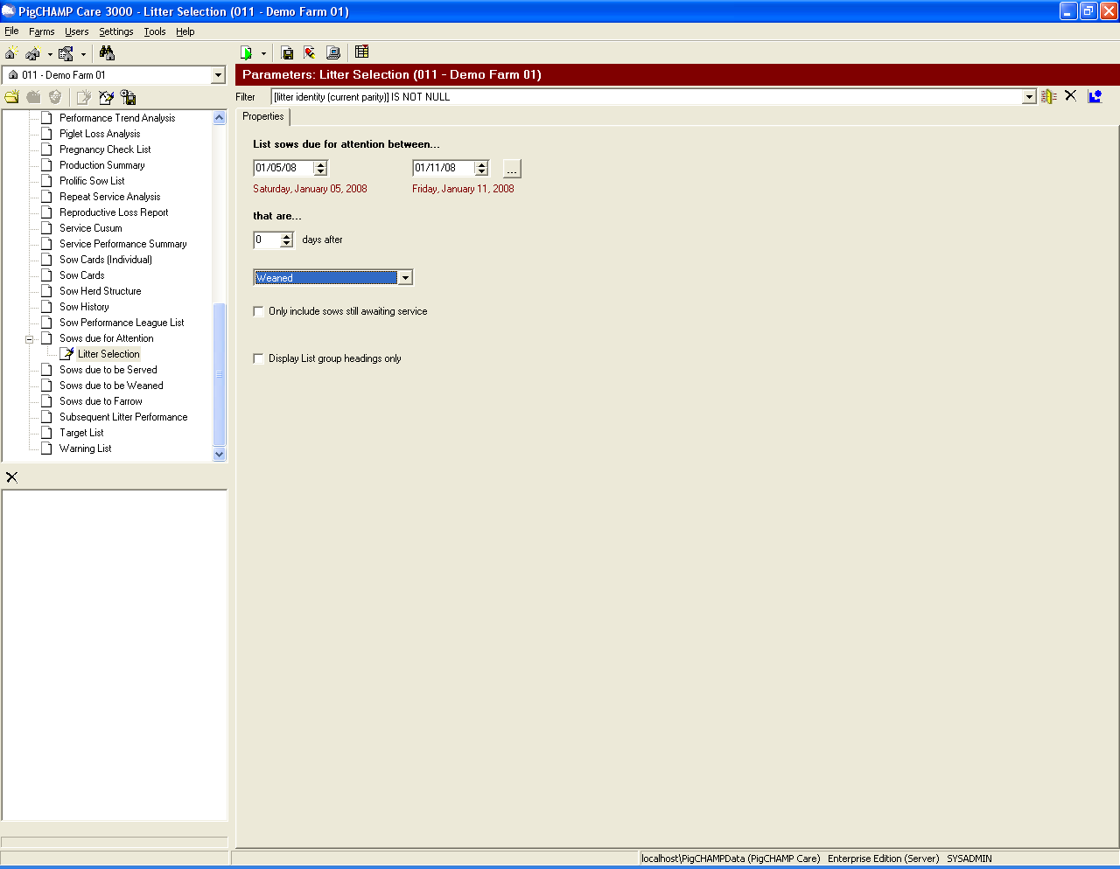

- Make sure that the properties are “0 days after weaned”

- You will need to set up the filter prior to the report being ran which you can do by clicking on the filter button

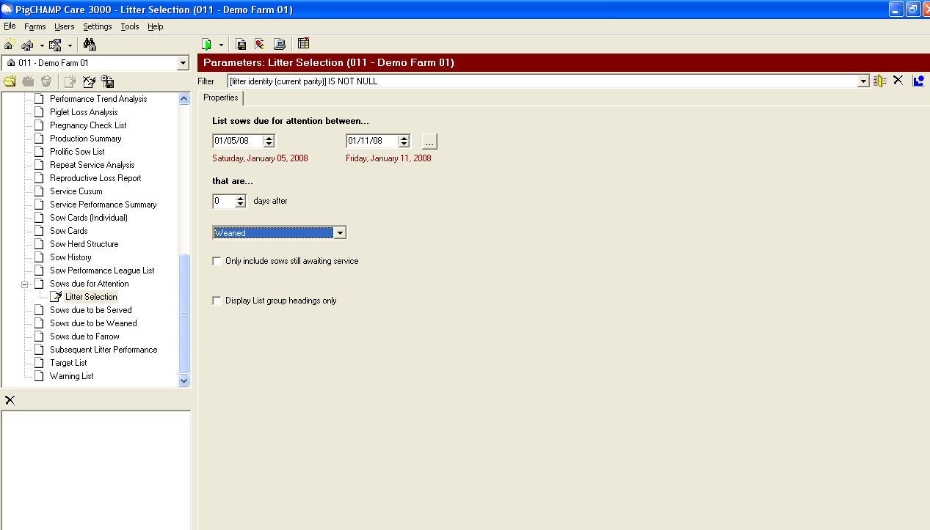

- Your Filter box will appear 20. In the SQL Operator you will want
and in the Reporting item pull to put “Is Not Null”
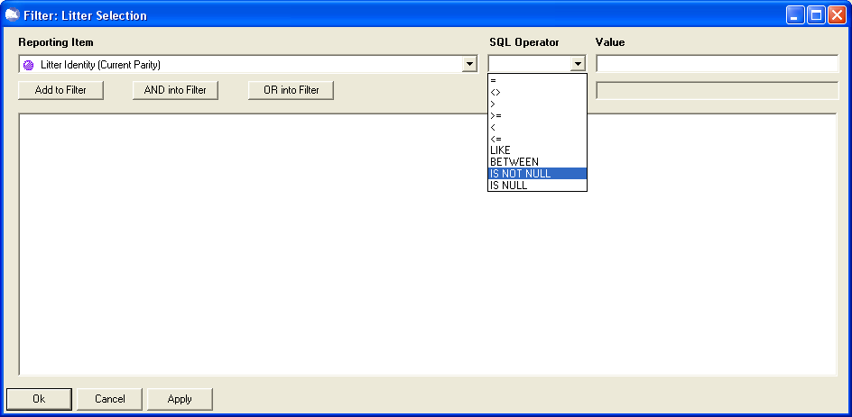
down box you will want to
put “Litter Identity”

- Click Add to Filter

- Click Apply

- Click OK

- Click Save Report Settings

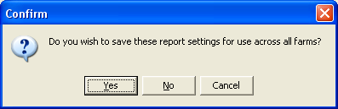

- When this confirmation box comes up click yes

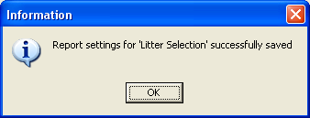

- Then you should get an information box
that says it saved successfully, click ok

- The only thing you should need to change on this report each time is the date that you want to run it for

- This will be what your report should look like if all these steps are followed

