By default, the program will automatically assign sows to a breeding group based on the date in which the sows were bred. The breeding week directly correlates to the Reporting week.

To establish your reporting weeks in the PigCHAMP Care 3000 program, follow the steps below:

- Click on the Farms Menu in the PigCHAMP Care 3000 Menu bar.
- Select Date Settings from the dropdown menu. The Date Settings screen will appear.
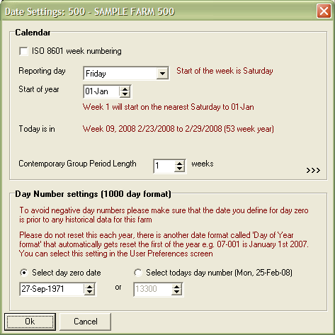
3
4

- Select your reporting day. The reporting day is the last day of the week.
- In the above example, the Reporting Day is Friday. This means that the week runs Saturday through Friday. Friday will be the last day of the breeding or reporting week.
- Select the first day of your year. The first week of the year will begin on the nearest day after the selected reporting day.
- In the example above, the start of the year is set as January 1st. This means that the first week of the year will begin on the Saturday nearest to January 1st.

Based on the above examples, the first week of 2008 was December 29th, 2007 through January 4th, 2008.

