- 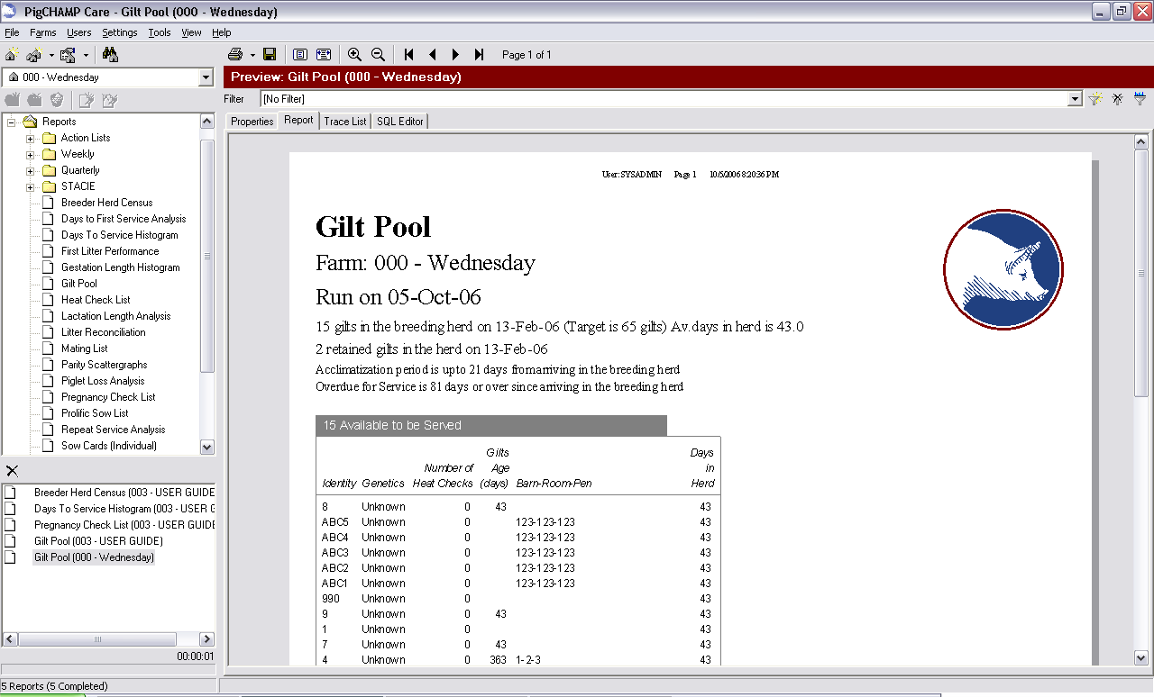 Save Report: Clicking on this icon (located in the Report Pre-View tool bar) will allow the user to save the report to a specified location, just as you would any word document. The report can be saved as a .PDF file or .EMF file. Select the desired output from the Save as Type dropdown menu on the Save Report screen.
  - The Adobe Acrobat reader must be installed on the computer in order to open a saved .PDF file.
  - The .EMF output is a Windows Metafile, designed to open in Windows Picture and Fax Viewer.

