Follow the instructions below to record the origin field to the an Arrival Event screen:

- Select the specific type of arrival event from the Arrival category. For this example, Gilt Arrival is being used.
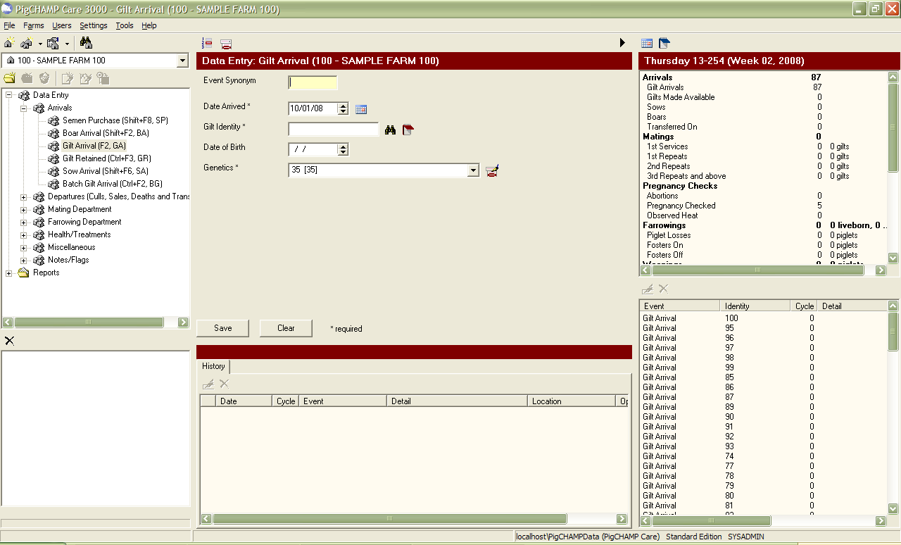

- Click on the Add Custom Data Items icon on the Arrival Event screen.

- The Data Item Management screen will appear.
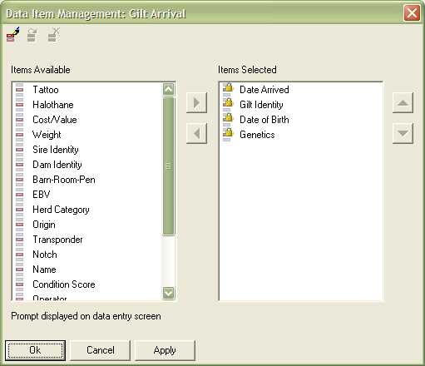
- Locate Origin in the Items Available category and click to highlight it.
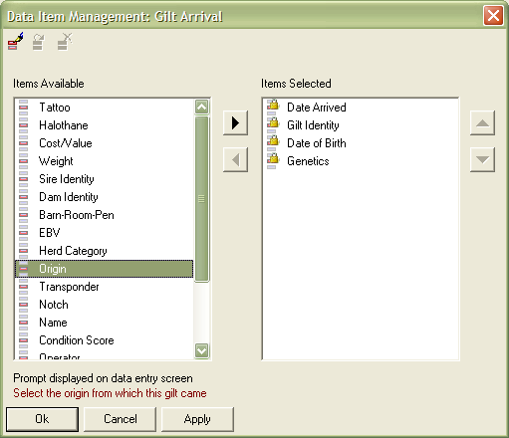

- Once Origin is highlighted, click on the arrow pointing to the right between the two columns.

- Origin will move from the Items Available to the Items Selected column.
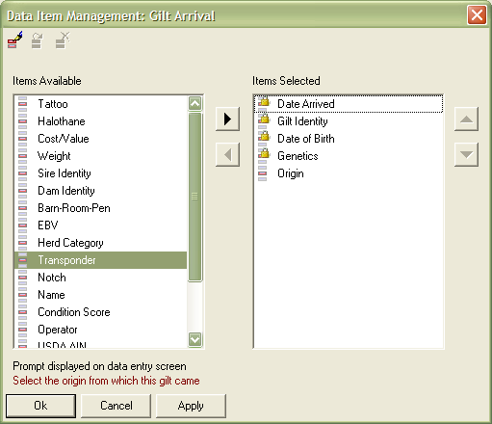

- If you wish to re-arrange the screen layout, use the up and down arrows to the right of the Items Selected box to move variables around. The order in which they appear in the Items Selected column indicates their position on the Arrival Event screen.
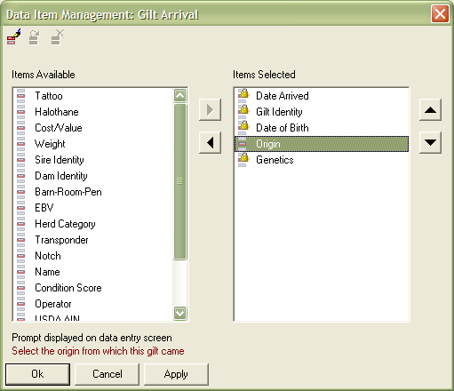

- Once all variables are in the desired position, click on the Apply button in the lower left hand corner of the screen, then click on OK.

- The Data Item Management screen will close and the Arrival Event screen will now include the Origin field in the desired position.
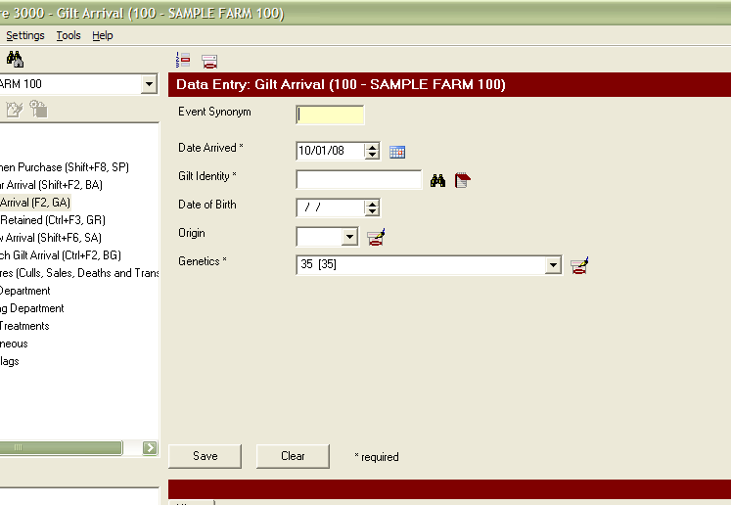

- You must now add variables to the Origin category in the Lookup Item Management. Click on the Lookup Item Management icon at the top of the data entry screen.

- The Lookup Item Management screen will appear.
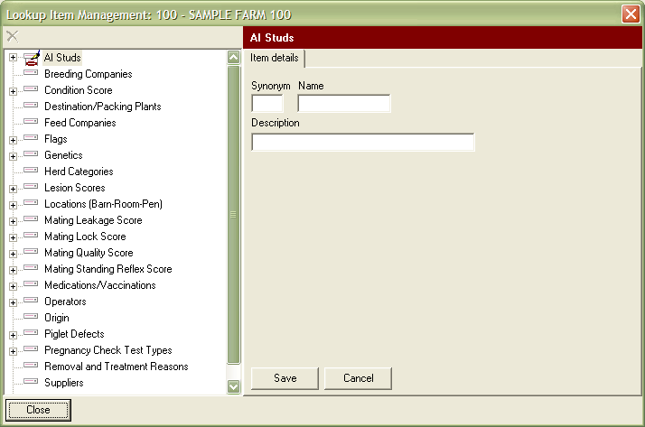

- Highlight the Origin category by clicking on it.
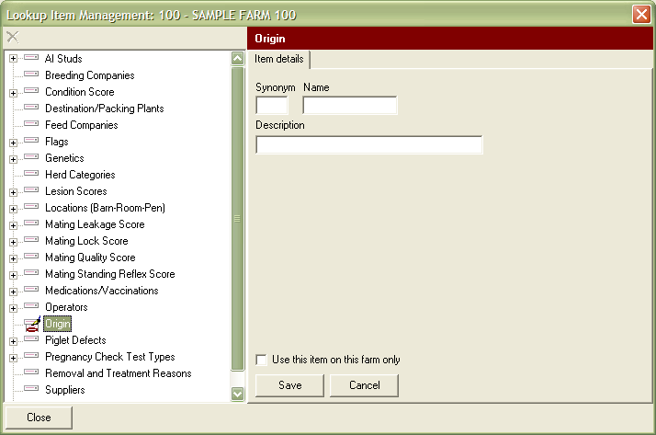

- The Origin category fields will appear to the right of the category list. Enter in a Synonym, Name, and Description of the origin to indicate the farm that provides your gilt/sows/boars.
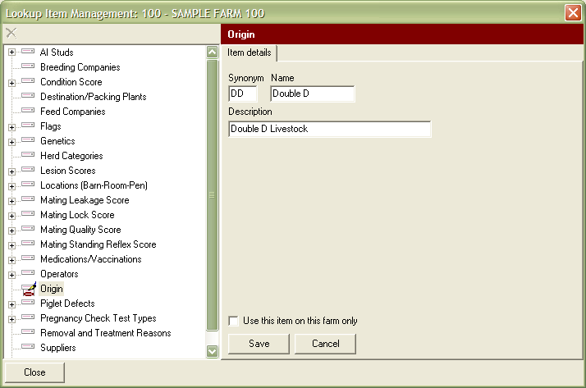

- Click on Save in the lower central portion of the screen.

- The new origin will be added to the list below the Origin category.
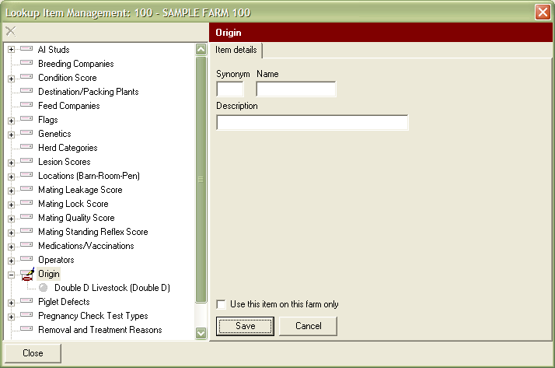

- If you wish to add more origins, repeat steps 13 and 14 until all have been established.

- Once all origins have been added to the Lookup Item List, click on Close in the lower left hand corner of the screen.

- The origin field dropdown list on the Arrival screen will now contain the created origins.
