Restart SQL Database

- Go to Start -> All Programs -> Microsoft SQL Server 2005 -> Configuration Tools -> SQL Server Configuration Manager
- Click on SQL Server 2005 Services in the left-hand pane.
- On the right-hand side, check the status of SQL Server (PIGCHAMPDATA).
- If the state says “Stopped” right-click on PIGCHAMPDATA. Select Start or Restart.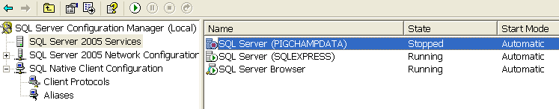

- If it starts, skip to step #7.
- If it gives an error that the service cannot start in a timely fashion, do the following:
  - Right click on SQL Server (PIGCHAMPDATA), choose Properties.
  - On the Log On tab, set Log On as: Built in Account: Local System. Click on Apply. Allow the service to restart if needed.
  - Make sure SQL Server(PigCHAMPDATA) now says LogOnAs: LocalSystem. If not, restart PigCHAMPDATA by right-clicking on it and choosing Restart (or Start if is currently stopped).
- Close out of the SQL Server Configuration Manager.
- Start Care 3000.

