64-bit Operating System Mobile Manager Pre-Installation

This procedure is only required if you are installing PigCHAMP Mobile Manager on a PC with a 64-bit operating system AND Care 3000 is not installed on this PC.

Check to see if you have a 64-bit Vista or Windows 7 operating system:

  - Go to Start button, click on Computer.
  - At the top of the screen, click on System Properties

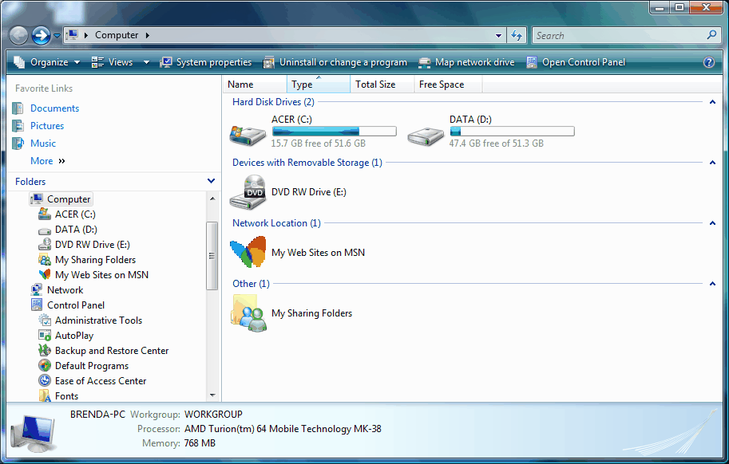

      - Look at System Type – this is the type of Vista or Windows 7 operating system you have. If you have a 64-bit operating system, continue. If it is 32-bit, discontinue this procedure and continue with PigCHAMP Mobile Manager software installation.

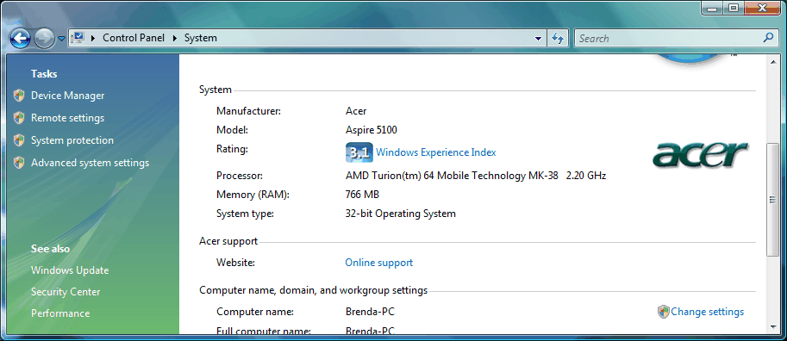

      - Close System Properties window.

Install Microsoft SQL Server 2005 Express (64-bit):

- On the Computer screen, right click on the CD drive. Choose Explore.
- Navigate to the SQLExpress-64 folder on the CD:
  - Start > Computer. Right click on CD-ROM, choose Explore.
  - Double click on SQLExpress-64
  - Double click on SQLEXPR.EXE.
- Accept EULA
- Click on Next button on each screen until you reach the screen that says “Registration Information” on the top.
  - The Name field must be filled in.
  - Company can be left blank.
  - Make sure the “Hide advanced configuration options” box is NOT checked.
  - Click Next.

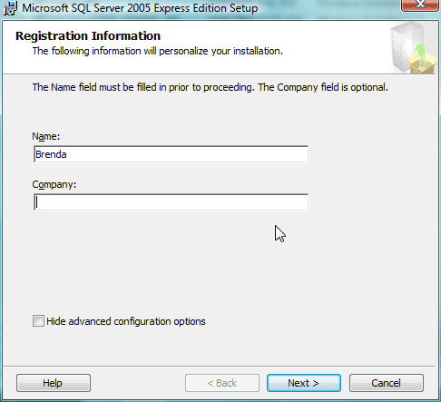

- Click Next on the Feature Selection screen.
- On the page that says “Instance Name”:
  - Choose Named Instance and type in: PIGCHAMPDATA
  - Click Next.
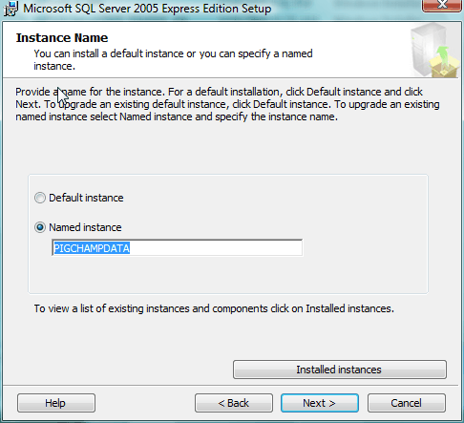

- On the screen that says “Service Account”
  - Use the built-in system account: Local system
  - Start services at the end of setup: Make sure both SQL Server and SQL Browser are checked.
  - Click Next.

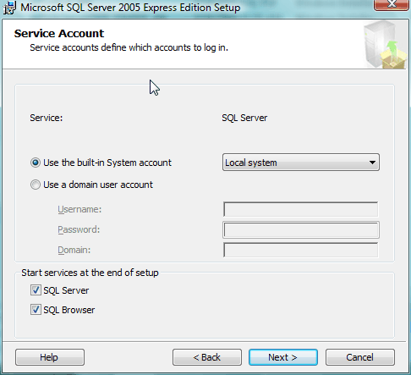

- On the page that says “Authentication Mode” choose Mixed Mode.
  - The password is: 4fiT5sJAdKm3.62 (password is case sensitive)
  - Click Next.

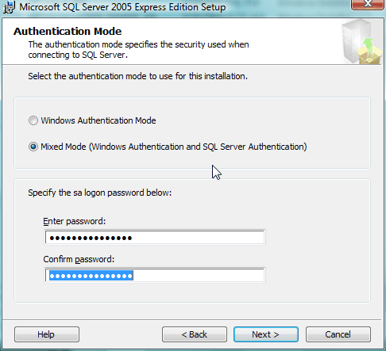

- Leave collation as is. Click Next.
- On the page that says “Configuration Options”:
  - Make sure both boxes are checked.
  - Click Next.
- Error and usage report settings:
  - No boxes checked.
  - Click Next.
- Click Install.
- Click Next.
- Click Finish.
- Click on Start > All Programs > Microsoft SQL Server 2005 > Configuration Tools > SQL Server Configuration Manager
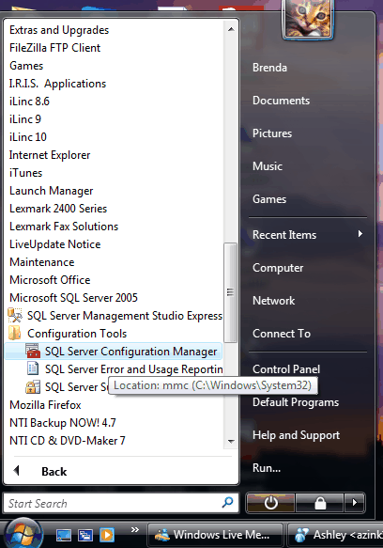

- Double click on SQL Server 2005 Network Configuration
- Double click on Protocols for PigCHAMPDATA
- Make sure all Protocol Status are enabled except VIA
  - If not enabled, right click on each item to change.
- If any Protocol Status was changed
  - Click SQL Server 2005 Services
  - Right click on PigCHAMPDATA
  - Choose restart.
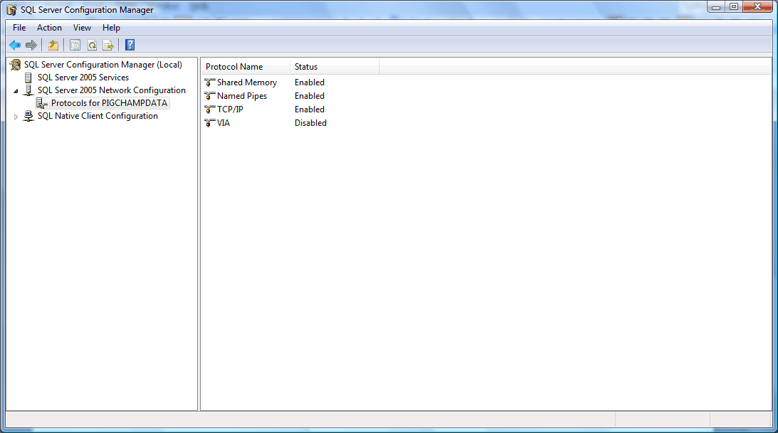

- Close SQL Configuration Manager.
- Continue with the PigCHAMP Mobile Manager software installation.

