Mobile Error

Error: “Unable to access database at HDM. Please check database settings (port, firewall access etc)”

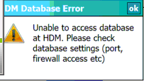

Solution:

When this error appears on the mobile it means it is unable to communicate with the Mobile Manager. One of the following should resolve the issue:

- Go through the section in the Mobile user guide pertaining to “Configure SQL” and “Firewall Settings.” If this does not fix it try step 2.

- Search for the location of the handheld.mdf and handheld_log.ldf files on the computer. Are they located under a folder other than the typical MSSQL.1, such as MSSQL.2 or MSSQL.3? If so, then you need to follow the steps under the “Firewall Settings” and add as an exception the sqlservr.exe found under the same MSSQL.# in which the .mdf and .ldf files reside.

