
Phone: 866-774-4242

Tech Support - Ext. 64Sales - Ext. 27
Forms/Supplies - Ext. 21Benchmarking Ext. - 22

www.pigchamp.com

HP IPAQ 111 SOFT AND HARD BOOT INSTRUCTIONS

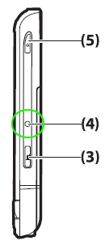
Soft Reset
NOTE: Close all the running applications before performing a soft reset.
A soft reset stops all running applications, but does not erase any programs or saved data.
To perform a soft reset:
1. Locate the recessed Reset button (4) on the HP iPAQ.
2. Use the stylus to lightly press the Reset button.
3. The iPAQ will restart and display the Today screen.

Hard Reset

NOTE: Back up all your data before performing a hard reset. A hard reset will remove all installed programs and erase any saved data.

- Press and hold the 3 buttons: Windows, OK and REC (REC is button 3 above)
- Using the stylus, press the reset button for about 3-4 seconds and release it (which is button 4 above)
- Release the 3 buttons.
- When it starts up you should see the words, “Clean Boot…” in green appear.

