
Phone: 866-774-4242

Tech Support - Ext. 64Sales - Ext. 27
Forms/Supplies - Ext. 21Benchmarking Ext. - 22

www.pigchamp.com

PSION SOFT AND HARD BOOT INSTRUCTIONS
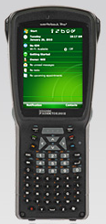
G3

Soft Reset

During a warm reset, running programs are halted. The contents of RAM, flash memory and the registry are preserved.

Press the FN/BLUE key and the ENTER key simultaneously for a few seconds.

Hard Reset

NOTE: Back up all your data before performing a hard reset. A hard reset will remove all installed programs and erase any saved data.

Press the SCAN bar, the FN/BLUE key, and ENTER key simultaneously for a few seconds.

